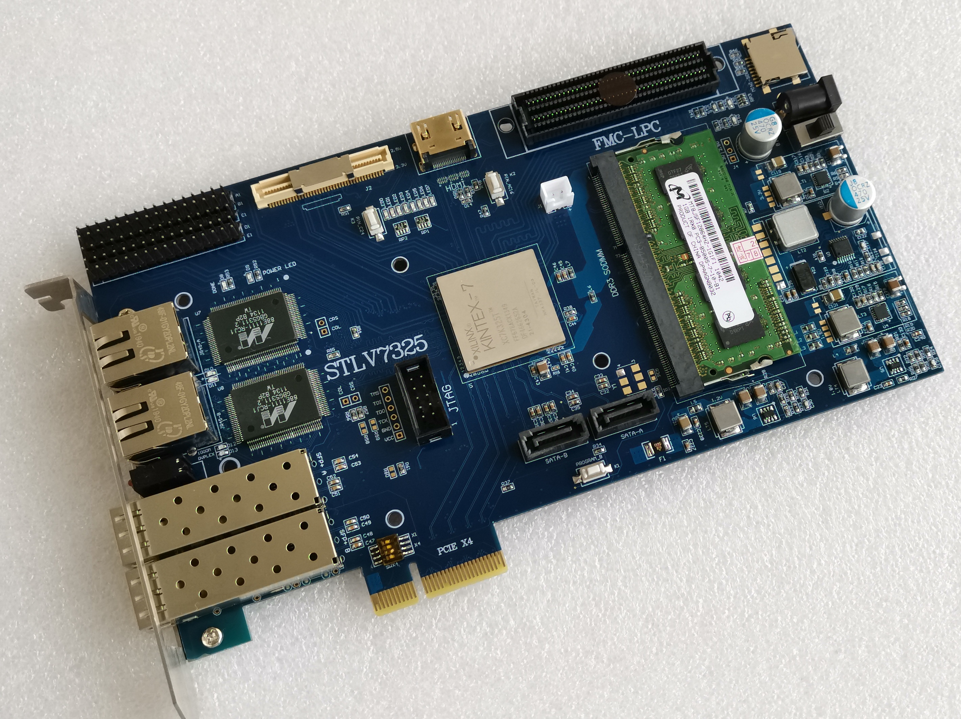
XC7K325T-FF676 FPGA Board introduction
FPGA XC7K325T-FFG6762I
DDR3 sodimm 64 bit memory module, supporting 1R or 2R stripe. Support ddr800 / 1066 / 1333 / 1600
The theoretical maximum bandwidth of DDR3 is 102.4Gbps
PCIe gen2.0 x 4 theoretical bandwidth 20Gbps
SFP 10Gbps optical fiber interface x2
88e1111 1000M network card x2
SATA 3.0 6Gbps X2
HDMI input (or ouput)
FMC LPC
MINI SD card
USB to TTL COM
BTB port GPIO
2.54 port GPIO
Key x2 input
LED X 8
100M single ended logic clock input
200M LVDS logic clock input
156.25M GTX refclk （sfp use）
150M GTX refclk （SATA use）
JTAG
N25Q256-3.3V QSPI X 4 Configuration chip
DC12V input
PCIe port can input DC12V

For the FPGA pins and levels corresponding to each interface of the board, please refer to another exls document to specify the corresponding pin positions

If users need to design their own sub modules, please note that FMC, HDMI, BTB board to board interface, 2.54 spacing pin and SD card interface, bank power supply are all the same power supply. By default, the board can modify 2.5V or 3.3V.

When users design their own sub modules, they should also pay attention to the line sequence, especially the power and ground, to avoid burning out the circuit board
The following J4 is to adjust the power supply of the GPIO, be sure to power off the setting.
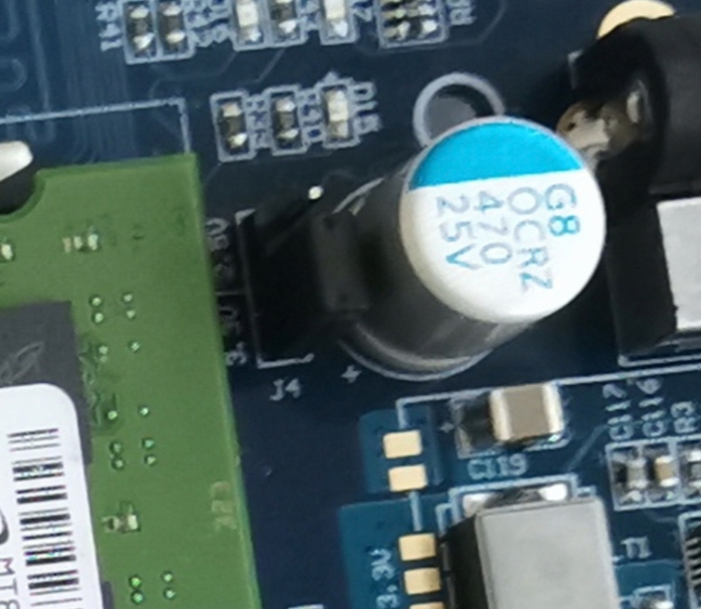
Remember to put the static electricity on your body in winter. It is recommended to use rubber stool or wooden stool instead of fur wrapped chair.

When using the 10 Gigabit network, make sure that the 10 Gigabit network card on the computer side is easy to use.

The thin code switch of the PCIe X1 / X4 can be set without caring about it. The motherboard will be automatically identified according to your program

Press the button down to low level. LED light is low level. If you find that led lights are not being used, they are faintly lit. You need to set it in the software to turn the unused IO to high level by default. That would not have happened.

If the user wants to replace the DDR3 memory module, you should pay attention to it when you take it and pay attention to it when you install it. The seat is very tight. No, look for the replacement video of DDR3 memory module on the Internet

When the board is inserted into the computer motherboard, there is no need for external power supply.

The same pair of Y3 differential crystal oscillator on board and GTX reference clock of FPGA connected with si5338 programmable clock. In other words, if the user does not use si5338, then Y3 can be pasted with a clock frequency required by the user. If the si5338 module is attached, the Y3 crystal oscillator cannot be used because it will be covered. Similarly, if you paste Y3 crystal oscillator, si5338 can no longer be pasted. They can only choose one of them.

About the network card test, I found two different codes on the Internet, the code architecture is similar. however

The top layer is rtl8211, and the entity is very stable. The top is rgmii, which is not very stable. It should be a problem of timing constraints. I will not change the details. I didn't go into the software.

The timing of 88e1111 and rtl8211 is the same, but the chip registers are different. If only using rgmii interface protocol. The timing is exactly the same.

